## **Phase-3**

## **Submission Template – Data Analytics**

**Student Name:** Manisha R

**Register Number:** 411823243010

**Insituation:** RRASE College of engineering

**Department:** B.tech (Artificial Intelligence and Data Science)

**Date of Submission:** 14/05/2025

**GitHub Repository Link:**

**1. Problem statement:**

Analyzing sports performance metrics to optimize team strategies and player selection in the Indian Premier League (IPL) is a multifaceted endeavor that combines data analytics, technology, and strategic planning. By leveraging advanced tools and methodologies, teams can enhance their decision-making processes, leading to improved performance and competitive advantage.

### 1. **Batting Metrics**

* **Strike Rate & Average**: Assessing a player's ability to score quickly and consistently.
* **Boundary Percentage**: Determining the frequency of boundaries hit, indicating aggressive play.
* **Match Situation Performance**: Evaluating a player's effectiveness in various match scenarios, such as power plays or death overs.

### 2. **Bowling Metrics**

* **Economy Rate & Strike Rate**: Measuring a bowler's ability to restrict runs and take wickets.
* **Dot Ball Percentage**: Indicating a bowler's effectiveness in building pressure.
* **Matchup Analysis**: Identifying favorable bowling matchups against specific batsmen. 3. **Fielding Metrics**

### 3. **Fielding Metrics**

* **Catches & Run Outs**: Quantifying a player's contribution to dismissals.
* **Ground Fielding Efficiency**: Assessing a player's ability to stop and return the ball quickly.
* **Throwing Accuracy**: Evaluating the precision of throws to the stumps.

### 4. **Fitness & Workload Metrics**

* **GPS Tracking Data**: Monitoring player movements, sprints, and fatigue levels.
* **Heart Rate Variability**: Assessing recovery and stress levels.
* **Injury Risk Indicators**: Identifying potential injury risks based on workload patterns.

**2. Abstract:**

The Indian Premier League (IPL) has evolved into a premier platform where data analytics and sports performance metrics play a pivotal role in shaping team strategies and player selection. This paper explores the integration of advanced analytical techniques to assess player performance, optimize team compositions, and formulate effective match strategies.

Key performance metrics such as batting strike rates, bowling economy rates, fielding efficiency, and player fitness levels are systematically analyzed to evaluate individual contributions and identify areas for improvement. Machine learning models, including Support Vector Machines (SVM), Random Forest, and K-Nearest Neighbors (KNN), are employed to predict player performance outcomes based on historical data, match conditions, and opponent analysis.

Furthermore, the Context-Aware Cricket Players Performance Metric (CAMP) is introduced as a novel approach to assess player impact by considering contextual factors such as match pressure and opposition strength. Empirical evaluations demonstrate that CAMP aligns closely with expert assessments, offering a more nuanced understanding of player contributions.

The application of these analytical frameworks enables IPL franchises to make data-driven decisions in player auctions, team selection, and in-match strategies. By leveraging comprehensive performance metrics and predictive models, teams can enhance their competitive edge, ensuring optimal utilization of player capabilities and fostering a strategic approach to match play.

In conclusion, the integration of sports performance metrics and advanced analytics is transforming the landscape of the IPL, facilitating a more scientific approach to team management and match strategy formulation. This paradigm shift underscores the importance of data-driven decision-making in achieving sustained success in professional cricket.

**3. System Requirements:**

To effectively analyze sports performance metrics and optimize team strategies and player selection for the Indian Premier League (IPL), a robust technological infrastructure is essential. This infrastructure should encompass hardware, software, data management, and network capabilities to support advanced analytics, machine learning models, and real-time data processing.

Hardware Requirements:

* **Processor (CPU)**: Intel Core i5 or i7 to handle intensive computations and parallel processing tasks.
* **Memory (RAM)**: Minimum of 32 GB for handling large datasets and running multiple applications simultaneously.

## Software and Development Tools:

* **Programming Languages**: Python for data analysis, statistical modeling, and machine learning.
* **Data Analysis Libraries**: Pandas, NumPy, for data manipulation and model development.
* **Data Visualization Tools**: Matplotlib, Seaborn, power BI for creating interactive dashboards and visualizations.
* **Database Management**: SQL for querying structured data and integrating.
* **Cloud Platforms**: Google collab for scalable data storage and processing.

## Network and Collaboration Tools:

* **Network Infrastructure**: Ensure high-speed internet connectivity with low latency for real-time data processing.
* **Collaboration Platforms**: Use tools like Microsoft Teams, communication and project management.
* **Cloud Storage**: Implement cloud storage solutions like Google Drive for sharing and storing data securely.

### **4. Project Objective:**

1. **Enhance Team Strategies**: Utilize data analytics to develop informed game plans tailored to team strengths and opposition weaknesses.
2. **Optimize Player Selection**: Employ performance metrics to identify players who can provide specific skills needed for match success.
3. **Predict Player Performance**: Implement predictive models to forecast individual player contributions in upcoming matches.
4. **Evaluate Match Outcomes**: Analyze historical data to understand factors influencing match results and team performance.
5. **Assess Player Form**: Monitor and evaluate players' current form to make timely decisions on team composition.
6. **Analyze Opposition Strengths**: Study opposing teams' strategies and player performances to devise counter-strategies.
7. **Simulate Match Scenarios**: Use data models to simulate various match situations and prepare strategies accordingly.
8. **Monitor Player Fitness**: Track players' fitness levels to ensure optimal performance and reduce injury risks.
9. **Enhance Fan Engagement**: Leverage data insights to create engaging content and interactive experiences for fans.
10. **Drive Data-Driven Decisions**: Foster a culture of data-driven decision-making to improve overall team performance and success.

### **5. Project Workflow (Flowchart):**

This workflow ensures a systematic approach to leveraging data analytics for enhancing team performance and strategic decision-making in the IPL.

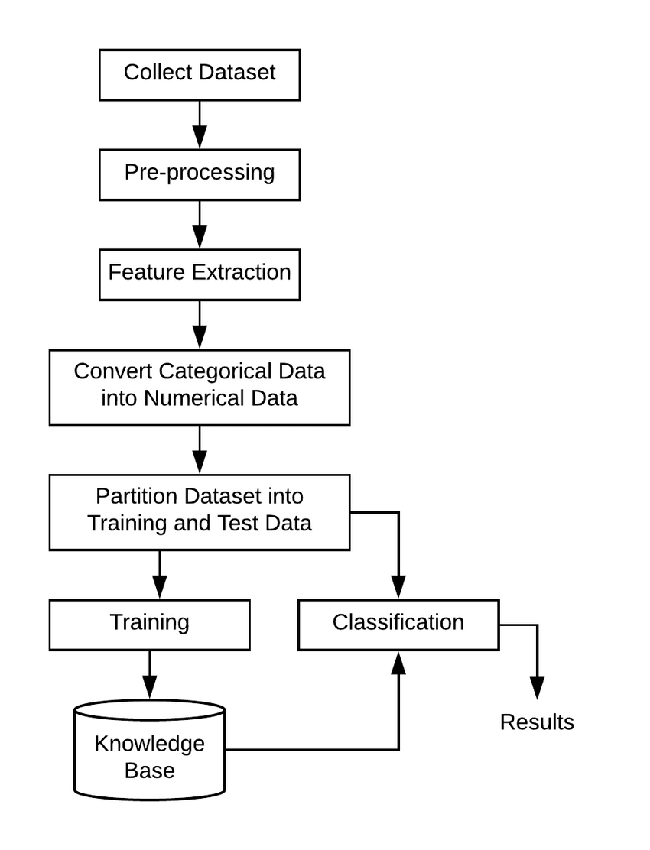**6. Dataset Description:**

* Dataset Name and Source: Kaggle
* Data Type: Structured
* Size: 754 records and 17 features
* static or dynamic nature: static
* Dataset Link: <https://www.kaggle.com/code/arnabpml/ipl-data-set-eda/input>
* Include a df.head() screenshot to show sample records.

### **7. Data Preprocessing:**

## 1. Data Cleaning

* **Handling Missing Values**: Use imputation methods (mean, median, mode) or remove rows/columns with missing data to ensure completeness.
* **Removing Duplicates**: Eliminate duplicate entries to maintain dataset integrity.
* **Correcting Inconsistencies**: Standardize data formats and correct erroneous entries (e.g., negative values in columns where they are not possible).

## 2. Data Transformation

* **Normalization**: Scale numerical features to a range of [0, 1] using techniques like Min-Max scaling to ensure all features contribute equally to the model.

* **Standardization**: Transform data to have a mean of 0 and a standard deviation of 1, which is useful for algorithms assuming a Gaussian distribution.
* **Encoding Categorical Variables**: Convert categorical data into numerical format using methods like One-Hot Encoding or Label Encoding to make them suitable for machine learning algorithms.

## 3. Feature Engineering:

* **Creating New Features**: Derive meaningful features from existing data, such as calculating batting strike rates, bowling economy rates, or player fitness score.
* **Aggregating Data**: Summarize data by grouping entities, often seen in time-series analysis, to capture trends and patterns over time.

## 4. Data Splitting:

* **Train-Test Split**: Divide the dataset into training and testing sets (commonly 70-30 or 80-20) to evaluate model performance on unseen data.
* **Cross-Validation**: Implement techniques like k-fold cross-validation to assess model robustness and prevent overfitting.

## 5. Model Selection and Evaluation:

* **Algorithm Selection**: Choose appropriate machine learning algorithms (e.g., Random Forest, Support Vector Machines) based on the problem type and data characteristics.
* **Performance Metrics**: Evaluate models using metrics such as accuracy, precision, recall, F1-score, and confusion matrix to determine effectiveness.

### **8. Exploratory Data Analysis (EDA):**

### **9. Insights and Interpretation:**

### **1. Strategic Player Selection:**

* **Data-Driven Auctions:** Teams utilize advanced analytics to assess players' historical performance metrics, including batting and bowling averages, strike rates, and economy rates. This approach aids in identifying players who can fulfill specific roles within the team, such as power hitters or death bowlers.
* **Hidden Talent Discovery:** Through statistical analysis, franchises can uncover underrated players who excel under particular conditions, like bowlers thriving on slower wickets or batsmen who can accelerate in the final overs.

### **2. Performance Monitoring and Optimization:**

* **Wearable Technology Integration:** Devices like GPS trackers and accelerometers monitor players' movements, workload, and physiological metrics. This data assists in tailoring training programs, preventing injuries, and ensuring players are in optimal condition.
* **Video Analysis Tools:** Platforms such as Catapult Pro Video integrate match footage with real-time data, enabling detailed analysis of batting, bowling, and fielding performances. Coaches can assess shot selection, bowling variations, and field positioning to refine strategies.

### **3. Tactical Strategy Formulation:**

* **Match Simulation and Predictive Analytics:** Teams employ machine learning models to simulate various match scenarios, considering factors like pitch conditions, opposition strengths, and player form. This predictive approach aids in making informed decisions regarding batting orders and bowling rotations.
* **Real-Time Decision Making:** During matches, data analytics provides insights into player performance, allowing for dynamic strategy adjustments. For instance, analyzing a bowler's economy rate can influence field placements and bowling rotations.

### **4. Case Studies and Real-World Applications:**

* **Mumbai Indians' Consistent Success:** The franchises sophisticated data analytics setup provides detailed reports on player performance and opposition analysis, aiding in team selection and match strategies.
* **Gujarat Titans' Rise:** Player Sai Sudharsan's performance exemplifies the impact of data-driven strategies. His balanced aggression, informed by analytics, has been pivotal in the team’s success.

### **10. Recommendations:**

1. **Advanced Player Profiling**: Utilize comprehensive metrics like batting and bowling averages, strike rates, economy rates, and match-winning abilities to assess player performance.
2. **Recent Form Analysis**: Prioritize players demonstrating consistent performance in recent matches and tournaments.
3. **Role-Specific Analysis**: Identify players who can fulfill specific roles within the team, such as openers, middle-order batters, all-rounders, fast bowlers, and spinners.
4. **Team Dynamics Consideration**: Evaluate how a player's style and personality integrate with the team's existing dynamics and culture.
5. **Future Potential Assessment**: Invest in young, promising players with high potential, even if they still need to establish themselves at the highest level.

1. **Machine Learning Models**: Employ algorithms like Random Forest, Support Vector Machines (SVM), and K-Nearest Neighbors (KNN) to forecast player performances based on historical data.
2. **Simulation Modeling**: Simulate different team compositions and strategies to assess their potential impact on match results.
3. **Context-Aware Metrics**: Implement metrics that consider the context of performance, such as opponents' strengths and specific circumstances of games, to quantify individual players' contributions toward a cricket match outcome.
4. **Clustering Techniques**: Apply clustering algorithms like k-means, hierarchical clustering, and DBSCAN to group players with similar performances, aiding in identifying patterns and making informed decisions.
5. **Big Data Analytics**: Process and analyze vast volumes of structured and unstructured data, including player statistics, game footage, social media interactions, and fan sentiment analysis, to extract meaningful insights.
6. **Computer Vision Technologies**: Utilize video analysis tools to study opponent strategies, player behavior under pressure, and areas for improvement, enhancing coaching strategies and player performance.
7. **Injury Prediction Models**: Implement predictive models to assess players' injury risks based on historical data, workload, and physiological metrics, ensuring player fitness and availability.
8. **Fan Engagement Analysis**: Analyze fan sentiment and engagement through social media and other platforms to gauge player popularity and marketability.
9. **Opponent Analysis**: Study opponents' strategies, strengths, and weaknesses to devise counter-strategies and gain a competitive edge.
10. **Real-Time Data Analytics**: Implement real-time analytics during matches to make immediate tactical adjustments and optimize team performance.
11. **Post-Match Analysis**: Conduct thorough post-match reviews using data analytics to identify areas of improvement and refine strategies for future matches.

**11.visualization dashboard:**

### **12.Team member and their roles:**

1. **Bharath Kumar -**Data cleaning
2. **Ranjith-**EDA
3. **Thirunavukarasu-**Feature Engineer
4. **Manisha -** Model development and visualization
5. **Vinith** - Documentation and reporting